**GENERAL HUMAN BIOLOGY – YEAR 11**

**TASK 6 – DIGESTION, NUTRITION AND EXCRETION TEST**

**NAME: ____________________________________ WEIGHTING: 10%**

**DATE: ____________________________________ MARK: _____ / 56 = _____ %**

***MULTIPLE CHOICE SECTION [10 MARKS]***

*Circle the correct answer (ie. a, b, c, or d) next to each question below:*

1. B
2. A
3. A
4. D
5. B
6. C
7. D
8. C
9. C
10. B

***SHORT ANSWER SECTION [40 MARKS]***

*Write your answers in the spaces provided below*

1. Label the following diagram in the spaces provided. (3 Marks

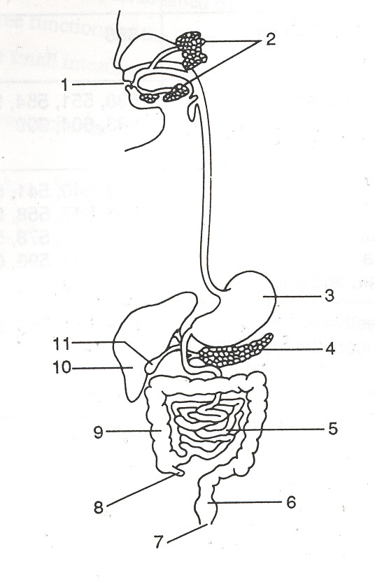

1. Mouth 9. Large intestine

3. Stomach 10. Liver

4. Pancreas 11. Gall bladder

1. Below is a table with three different foods. Complete the table with the information required about each of the foods. (6 marks)

|  |  |  |  |  |
| --- | --- | --- | --- | --- |
| Food | Food group | What is the simplest form it is broken down into | Enzyme that breaks it down | Where in the body does it **BEGIN** to chemically digest |
| Meat | protein | Amino acids | Protease/pepsin | Stomach |
| Butter | Lipids/fats | Fatty acids and glycerol | lipase | Small intestine |
| Fruit | carbohydrate | Monosaccharides | amylase | Mouth |

1. The body uses both mechanical and chemical digestion to release nutrients from our food which will eventually be absorbed by our cells.

* 1. Name three locations where mechanical digestion occurs. (3 marks)

*1 mark per point*  
Any three of the following:

* Mouth
* Oesophagus
* Stomach
* Small intestine
  1. Choose one of your locations and explain how mechanical digestion occurs (2 marks)

2 marks = concise explanation, scientific language, no errors

1 mark = brief explanation, some scientific language, some errors

0 marks = no attempt OR wrong explanation

* 1. How does mechanical digestion help chemical digestion to occur? (3 marks)

Mechanical digestion breaks food into smaller pieces (1)

Creates a larger surface area (1)

Allows chemicals/enzymes to act on food (1)

1. There are 5 essential nutrients that we get from the foods we eat. List the5 essential nutrients in the space below. (3 marks)

|  |  |  |  |
| --- | --- | --- | --- |
| **1-** | Carbohydrate | **4-** | Water |
| **2-** | Protein | **5-** | Vitamins and Minerals |
| **3-** | Lipids |  |  |

1. For two of any of the above listed essential nutrients, state what their function in the human body is: (4 marks)

2 marks per nutrient.

*2 marks = accurate and scientific*

*1 mark = some error OR not scientific*

*0 marks = no attempt OR completely wrong*

* carbohydrates: used as an energy source, for storage and for fibre/roughage
* proteins: used for growth and repair of tissues and as components of cell structures, hormones and enzymes
* fats (lipids): used in the formation of cell membranes, as an energy source and a storage material
* vitamins and minerals, including calcium and iron, used in many various roles
* water: the main solvent in the body, which also has many other uses in the body

1. 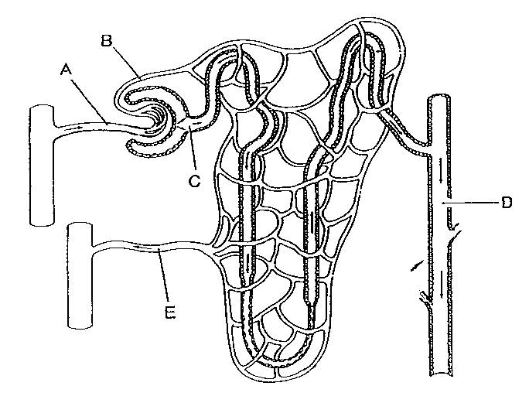Below is a diagram of a structure found inside the kidney

What is the name of this entire structure? (1 mark)

* Nephron  
  1. Name the following parts of the above structure. (2 marks)  
     1. Proximal convoluted tubule
     2. Distal convoluted tubule
     3. Collecting duct
     4. Loop of Henle

* 1. Explain the three processes that occur in the above structure. (4 marks)  
     1 mark for all three processes stated – filtration, reabsorption, secretion

1 mark for each correct description

* Filtration – materials (such as small molecules and water) forced out of the blood into the nephron through the capsule.
* Reabsorption – materials needed by the body in the nephron are reabsorbed back into the blood.
* Secretion – materials that were too large to pass through the capsule or are toxic to the body are secreted into the nephron for excretion.

1. The table below shows the concentrations of dissolved substances in the urine of a healthy person and the urine of a person with one type of kidney disease.

|  |  |  |
| --- | --- | --- |
| Substance | Concentration in grams per dm3 | |
| Urine of a healthy person | Urine of a person with kidney disease |
| Protein | 0 | 6 |
| Glucose | 0 | 0 |
| Amino acids | 0 | 0 |
| Urea | 21 | 21 |
| Mineral ions | 19 | 19 |

* + 1. Suggest an explanation for the difference in composition of the urine between the healthy person and the person with kidney disease. (3 marks)
* In the healthy person, the capsule stops protein from entering the nephron (1)
* In the person with kidney disease the capsule is not working correctly and protein is let through (1)
* It is not a material that is reabsorbed so it is excreted (1)  
  + 1. The person with the kidney disease could be treated either by using a dialysis machine or by a kidney transplant operation.  
       1. Describe each treatment. (2 marks)  
          1 mark per accurate description = 2 marks total
       2. Give 2 advantages and 2 disadvantages for each treatment. (4 marks)

½ mark per advantage per treatment = 2 marks

½ mark per disadvantage per treatment = 2 marks

***EXTENDED ANSWER SECTION [6 MARKS]***

1. You have been given a separate piece of paper that contains the suggested servings per day of each of the Five Food Groups and examples of what is considered one serving.   
     
   Using the information on the sheet, create a healthy food plan for a **14-18 year old male student**. The plan is for one day only.

|  |  |
| --- | --- |
| Behaviours | Marks |
| Correct servings  Variety of foods  Healthy  Correct gender and age | 6 |
| As above BUT slightly incorrect  (e.g. servings OR gender/age) | 4 |
| Attempted Plan with some variety and healthy options | 2 |
| Nothing OR Plan with no variety/not healthy | 0 |